Exercise 2: Comments and Pound Characters

1. Find out if you were right about what the # character does and make sure you know what it's called (octothorpe or pound character).

**Answer: The # character is comment out the code and disables line of the program. Code with Pound (#) character will not be run by Ruby.**

1. Take your ex2.rb file and review each line going backward. Start at the last line, and check each word in reverse against what you should have typed.

**Answer: Done.**

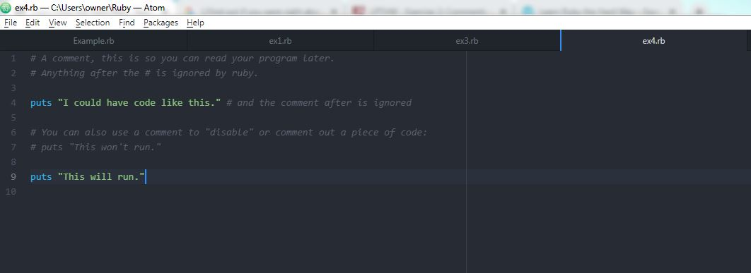

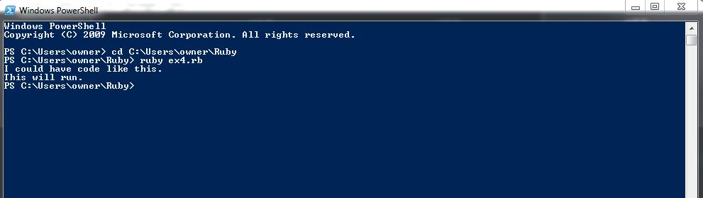

1. Did you find more mistakes? Fix them.

**Answer: No mistakes.**

1. Read what you typed above out loud, including saying each character by its name. Did you find more mistakes? Fix them.

**Answer: None.**